Form NMB-2 OMB No. 3140-0002 (Expiration Date 08/31/2020)
Mail to: Or fax to:
Mediation Department Mediation – 202-692-5084
National Mediation board
1301 k Street NW, Suite 250 E. email:mediation@nmb.gov
Washington, DC 20005

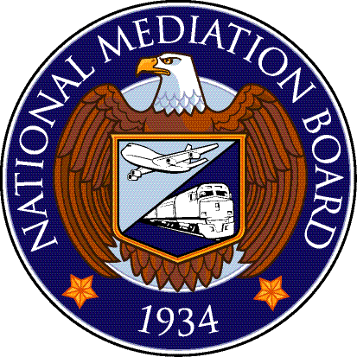

Application for Mediation Services

TO THE NATIONAL MEDIATION BOARD, Washington, D. C. 20005: A dispute has arisen between the parties shown below which has not been adjusted between them, and the services of the National Mediation Board under Section 5, First, of the Railway Labor Act, are hereby invoked on specific questions set forth below. The approximate number of employees involved is _______________ in the craft(s) or class(es) of

___________________________________________________________.

THE SPECIFIC ISSUE(S) IN DISPUTE (If necessary extend question on additional sheet or attach exhibit):

PARTIES TO DISPUTE

 | Carrier |  | Organization/Individual
Carrier Name |  | Organization Name
L. R. Official/Title |  | Organization Official/Title
Address |  | Address
City, State and Zip Code |  | City, State and Zip Code
Telephone |  | Telephone
Fax |  | Fax
Email |  | Email

WORKING AGREEMENT

If an agreement governing rates of pay, rules, or working conditions is in effect, give name of parties thereto and date thereof. If there is no such

agreement, so state ___________________________________________.

COMPLIANCE WITH RAILWAY LABOR ACT

- If this dispute involves change in the above-mentioned agreement, attach copy of the 30-day notice served by party desiring change and insert date of notice here _________________________________________________________________________________________________.

- If this dispute involves the negotiation of a new or supplemental agreement, attach copy of request made by party desiring same and insert date of request here ____________________________________________________________________________________________________.

- If there has been refusal to confer, so state and give reason; otherwise, give date of last conference here _____________________________.

Signed at _______________________________________________________ this ________________ of _______________ 20________.
(City and State) (Day) (Month)

 | Carrier Official | Organization Official
Name:
Title:
Signature:

Filing Instructions: File this application in duplicate. Additional Sheets: Use and attach additional sheets as needed.

According to the Paperwork Reduction Act of 1995, no persons are required to respond to a collection of information unless it displays a valid OMB control Number. The valid OMB control number for this information collection is 3140-0002. The time required to complete this information collection is estimated to average 15 minutes per response, including the time to review instructions, search existing data resources, gather the data needed, and complete and review the information collection.

Updated October 27, 2008

